Assignment No.:1

Name: Kudal Vaibhav Sonaji
Roll No.: CO-433
Class:- BE COMP (A)

Title: Predict the price of the Uber ride from a given pickup point to the agreed drop-off location.
Perform following tasks:
- Pre-process the dataset.
- Identify outliers.
- Check the correlation.
- Implement linear regression and random forest regression models.
- Evaluate the models and compare their respective scores like R2, RMSE, etc.
Dataset link: https://www.kaggle.com/datasets/yasserh/uber-fares-dataset

Importing the Libraries

In [1]: |  | import pandas as pd  import numpy as np  import matplotlib.pyplot as plt # for creating visualizations
 |  | import seaborn as sns # for drawing attractive and informative statis
 |  | Importing the dataset
In | [2]: | df = pd.read_csv("uber.csv")
In | [3]: | df

Out[3]: Unnamed: 0
key fare_amount pickup_datetime pickup_longitude pickup_latitude dropoff_l

0 24238194 2015-05-07
19:52:06.0000003
7.5 2015-05-07
19:52:06 UTC

-73.999817 40.738354 -

1 27835199
2009-07-17
20:04:56.0000002
7.7
2009-07-17
20:04:56 UTC
-73.994355
40.728225
-

2 44984355 2009-08-24
21:45:00.00000061
12.9 2009-08-24
21:45:00 UTC
-74.005043 40.740770 -

3 25894730
2009-06-26
08:22:21.0000001
5.3
2009-06-26
08:22:21 UTC
-73.976124
40.790844
-

4 17610152 2014-08-28
17:47:00.000000188
16.0 2014-08-28
17:47:00 UTC
-73.925023 40.744085 -

... ... ... ... ... ... ...

3.0 2012-10-28
199995 | 42598914 2012-10-28  10:49:00.00000053
199996 | 16382965 2014-03-14  01:09:00.0000008
199997 | 27804658 2009-06-29

-73.987042 | 40.739367 | -
-73.984722 | 40.736837 | -
-73.986017 | 40.756487 | -

10:49:00 UTC

7.5
2014-03-14
01:09:00 UTC

00:42:00.00000078
30.9 2009-06-29
00:42:00 UTC

04:08:00.00000076 04:08:00 UTC
14:56:25.0000004 14:56:25 UTC
199998 20259894 2015-05-20 14.5 2015-05-20 -73.997124 | 40.725452 | -
199999 11951496 2010-05-15 14.1 2010-05-15 -73.984395 | 40.720077 | -

200000 rows × 9 columns

Pre-process the dataset

In [4]:
df.head() ## to get 1st five rows

Out[4]: Unnamed: 0

key fare_amount pickup_datetime pickup_longitude pickup_latitude dropoff_longit

0 24238194 2015-05-07
19:52:06.0000003
7.5 2015-05-07
19:52:06 UTC

-73.999817 40.738354 -73.999

1 27835199
2009-07-17
20:04:56.0000002
7.7
2009-07-17
20:04:56 UTC
-73.994355
40.728225
-73.994

2 44984355 2009-08-24
21:45:00.00000061
12.9 2009-08-24
21:45:00 UTC
-74.005043 40.740770 -73.962

3 25894730
2009-06-26
08:22:21.0000001
2009-06-26
08:22:21 UTC
-73.976124

4 17610152 2014-08-28
17:47:00.000000188
16.0 2014-08-28
17:47:00 UTC
-73.925023 40.744085 -73.973

In [5]:
df.tail() ## to get last five rows

mount pickup_datetime
Out[5]: |  | Unnamed: key fare_a 0
 | 199995 | 42598914 2012-10-28  10:49:00.00000053
 | 199996 | 16382965 2014-03-14  01:09:00.0000008
 | 199997 | 27804658 2009-06-29  00:42:00.00000078
 | 199998 | 20259894 2015-05-20  14:56:25.0000004
 | 199999 | 11951496 2010-05-15

pickup_longitude | pickup_latitude | dropoff_lo
-73.987042 | 40.739367 | -7
-73.984722 | 40.736837 | -7
-73.986017 | 40.756487 | -7
-73.997124 | 40.725452 | -7
-73.984395 | 40.720077 | -7

3.0 2012-10-28
10:49:00 UTC

7.5
2014-03-14
01:09:00 UTC
30.9 2009-06-29
00:42:00 UTC
14.5
2015-05-20
14:56:25 UTC

04:08:00.00000076
14.1 2010-05-15
04:08:00 UTC

In [6]:
df.info() ## To get te required informtion of the dataset.
<class 'pandas.core.frame.DataFrame'> RangeIndex: 200000 entries, 0 to 199999 Data columns (total 9 columns):
# Column Non-Null Count Dtype
0 |  | Unnamed: | 0 | 200000 | non-null | int64
1 |  | key |  | 200000 | non-null | object
2 fare_amount |  |  |  | 200000 | non-null | float64
3 pickup_datetime |  |  |  | 200000 | non-null | object
4 pickup_longitude |  |  |  | 200000 | non-null | float64

5 pickup_latitude | 200000 | non-null | float64
6 dropoff_longitude | 199999 | non-null | float64
7 dropoff_latitude | 199999 | non-null | float64
8 passenger_count 200000 non-null int64 dtypes: float64(5), int64(2), object(2)
memory usage: 13.7+ MB
In [7]:
df.columns # To get all the column names from the dataset

Out[7]:

In [8]:
Index(['Unnamed: 0', 'key', 'fare_amount', 'pickup_datetime', 'pickup_longitude', 'pickup_latitude', 'dropoff_longitude', 'dropoff_latitude', 'passenger_count'],
dtype='object')
df = df.drop(['Unnamed: 0', 'key'], axis= 1) ##To drop unnamed column as it isn't re

In [9]:
df

Out[9]: fare_amount pickup_datetime pickup_longitude pickup_latitude dropoff_longitude dropoff_latitude pas

0 7.5 2015-05-07
19:52:06 UTC

-73.999817 40.738354 -73.999512 40.723217

1
7.7
2009-07-17
20:04:56 UTC
-73.994355
40.728225
-73.994710
40.750325

2 12.9 2009-08-24
21:45:00 UTC
-74.005043 40.740770 -73.962565 40.772647

3
5.3
2009-06-26
0
8:22:21 UTC
-73.976124
40.790844
-73.965316
40.803349

4 16.0 2014-08-28
17:47:00 UTC
-73.925023 40.744085 -73.973082 40.761247

... ... ... ... ... ... ...

199995 3.0 2012-10-28
10:49:00 UTC
-73.987042 40.739367 -73.986525 40.740297

199996
7.5
2014-03-14
01:09:00 UTC
-73.984722
40.736837
-74.006672
40.739620

199997 30.9 2009-06-29
00:42:00 UTC
-73.986017 40.756487 -73.858957 40.692588

199998
14.5
2015-05-20
14:56:25 UTC
-73.997124
40.725452
-73.983215
40.695415

199999 14.1 2010-05-15
04:08:00 UTC
-73.984395 40.720077 -73.985508 40.768793

200000 rows × 7 columns

In [10]:
df.head() # To get the 1st five rows

Out[10]: fare_amount pickup_datetime pickup_longitude pickup_latitude dropoff_longitude dropoff_latitude passenge

0 | 7.5 2015-0 -07 -73.999817 40.738354 -73.999512 40.723217  19:52:06 UTC
1 | 7.7 2009-0 -17 -73.994355 40.728225 -73.994710 40.750325  20:04:56 UTC
2 | 12.9 2009-0 -24 -74.005043 40.740770 -73.962565 40.772647  21:45:00 UTC

17:47:00 UTC
08:22:21 UTC
3 5.3 2009-06-26 -73.976124 | 40.790844 | -73.965316 | 40.803349
4 16.0 2014-08-28 -73.925023 | 40.744085 | -73.973082 | 40.761247

In [11]:
df.shape ## To get the number of rows and columns

Out[11]:

In [12]:

Out[12]:

In [13]:
(200000, 7)
df.dtypes ## To get the data type of each column
fare_amount float64
pickup_datetime object pickup_longitude float64 pickup_latitude float64 dropoff_longitude float64 dropoff_latitude float64
passenger_count int64 dtype: object
df.describe() ## Returns description of the data in dataframe

Out[13]: | fare_amount | pickup_longitude | pickup_latitude | dropoff_longitude | dropoff_latitude | passenger_count
count | 200000.000000 | 200000.000000 | 200000.000000 | 199999.000000 | 199999.000000 | 200000.000000
mean | 11.359955 | -72.527638 | 39.935885 | -72.525292 | 39.923890 | 1.684535
std | 9.901776 | 11.437787 | 7.720539 | 13.117408 | 6.794829 | 1.385997
min | -52.000000 | -1340.648410 | -74.015515 | -3356.666300 | -881.985513 | 0.000000
25% | 6.000000 | -73.992065 | 40.734796 | -73.991407 | 40.733823 | 1.000000
50% | 8.500000 | -73.981823 | 40.752592 | -73.980093 | 40.753042 | 1.000000
75% | 12.500000 | -73.967154 | 40.767158 | -73.963658 | 40.768001 | 2.000000
max | 499.000000 | 57.418457 | 1644.421482 | 1153.572603 | 872.697628 | 208.000000

Handling missing values

In [14]:
df.isnull().sum() #used to check missing values in dataframe

Out[14]:

In [15]:
df['dropoff_latitude'].fillna(value=df['dropoff_latitude'].mean(),inplace
=
True) ## fi
df['dropoff_longitude'].fillna(value=df['dropoff_longitude'].median(),inplace = True)
fare_amount 0
pickup_datetime | 0
pickup_longitude | 0
pickup_latitude | 0
dropoff_longitude | 1
dropoff_latitude | 1
passenger_count  dtype: int64 | 0

In [16]:
df.isna().sum()

Out[16]: fare_amount 0
pickup_datetime 0
pickup_longitude 0

 | pickup_latitude | 0
 | dropoff_longitude | 0
 | dropoff_latitude | 0
 | passenger_count | 0
 | dtype: int64
In [17]: | df.dtypes
Out[17]: | fare_amount pickup_datetime | float64 object
 | pickup_longitude | float64
 | pickup_latitude | float64
 | dropoff_longitude | float64
 | dropoff_latitude | float64
 | passenger_count | int64
 | dtype: object

Column pickup_datetime is in wrong format i.e object format.
Change it into datetime format

In [18]:
df.pickup_datetime = pd.to_datetime(df.pickup_datetime, errors='coerce') ##coerce - conv

In [19]:

Out[19]:

In [20]:
df= df.assign(hour = df.pickup_datetime.dt.hour,
day = df.pickup_datetime.dt.day, month= df.pickup_datetime.dt.month, year = df.pickup_datetime.dt.year,
dayofweek= df.pickup_datetime.dt.dayofweek)

fare_amount float64
df.dtypes
pickup_datetime datetime64[ns, UTC] pickup_longitude float64
pickup_latitude float64
dropoff_longitude float64
dropoff_latitude float64
passenger_count int64
dtype: object

To segregate each time of date and time

In [21]:
df.head()

Out[21]: fare_amount pickup_datetime pickup_longitude pickup_latitude dropoff_longitude dropoff_latitude passenge

0 7.5 2015-0 -07 -73.999817  19:52:06+00:00 | 40.738354 | -73.999512 | 40.723217
1 7.7 2009-0 -17 -73.994355  20:04:56+00:00 | 40.728225 | -73.994710 | 40.750325
2 12.9 2009-0 -24 -74.005043  21:45:00+00:00 | 40.740770 | -73.962565 | 40.772647
3 5.3 2009-0 -26 -73.976124  08:22:21+00:00 | 40.790844 | -73.965316 | 40.803349

4 16.0 2014-08-28
17:47:00+00:00
-73.925023 40.744085 -73.973082 40.761247

In [22]:
# UTC stands for Coordinated Universal Time. It is a standard format used to establish t

Drop the column 'pickup_datetime' using drop()

In [23]:
# 'axis = 1' drops the specified column

df = df.drop('pickup_datetime',axis=1) df

Out[23]: | fare_amount | pickup_longitude | pickup_latitude | dropoff_longitude | dropoff_latitude | passenger_count | ho
 | 0 7.5 | -73.999817 | 40.738354 | -73.999512 | 40.723217 | 1 | 1
 | 1 7.7 | -73.994355 | 40.728225 | -73.994710 | 40.750325 | 1 | 2
 | 2 12.9 | -74.005043 | 40.740770 | -73.962565 | 40.772647 | 1 | 2
 | 3 5.3 | -73.976124 | 40.790844 | -73.965316 | 40.803349 | 3
 | 4 16.0 | -73.925023 | 40.744085 | -73.973082 | 40.761247 | 5 | 1
 | ... ... | ... | ... | ... | ... | ...
199995 3.0 |  | -73.987042 | 40.739367 | -73.986525 | 40.740297 | 1 | 1
199996 7.5 |  | -73.984722 | 40.736837 | -74.006672 | 40.739620 | 1
199997 30.9 |  | -73.986017 | 40.756487 | -73.858957 | 40.692588 | 2
199998 14.5 |  | -73.997124 | 40.725452 | -73.983215 | 40.695415 | 1 | 1
199999 14.1 |  | -73.984395 | 40.720077 | -73.985508 | 40.768793 | 1

200000 rows × 11 columns

In [24]:
# function to calculate the travel distance from the longitudes and latitudes

from math import * # imports all functions, constants, and classes from the math modul
def distance_formula(longitude1, latitude1, longitude2, latitude2): travel_dist = []
for pos in range (len(longitude1)):
# Convert degrees to radians
lon1, lan1, lon2, lan2 = map(radians, [longitude1[pos], latitude1[pos], longitud
# Differences in longitude and latitude
dist_lon = lon2 - lon1 dist_lan = lan2 - lan1
#Haversine formula
#The Haversine formula is used to calculate the great-circle distance between tw #given their latitudes and longitudes.
a = sin(dist_lan/2)**2 + cos(lan1) * cos(lan2) * sin(dist_lon/2)**2
# Radius of Earth in kilometers = 6371
c = 2 * asin(sqrt(a)) * 6371 travel_dist.append(c)

return travel_dist
In [25]:
# This line of code takes the pickup and dropoff coordinates from your DataFrame #calculates the distance between each pair using the distance_formula function, and then
df['dist_travel_km'] = distance_formula(df.pickup_longitude.to_numpy(), df.pickup_latitu

In [26]:
df.dtypes

Out[26]:

In [27]:
df.plot(kind = "box",subplots = True,layout = (6,2),figsize=(15,20)) #Boxplot to check t
plt.show()
fare_amount float64 pickup_longitude float64 pickup_latitude float64 dropoff_longitude float64 dropoff_latitude float64
passenger_count int64
hour int32
day int32
month int32
year int32
dayofweek int32 dist_travel_km float64 dtype: object

Identify the outliers

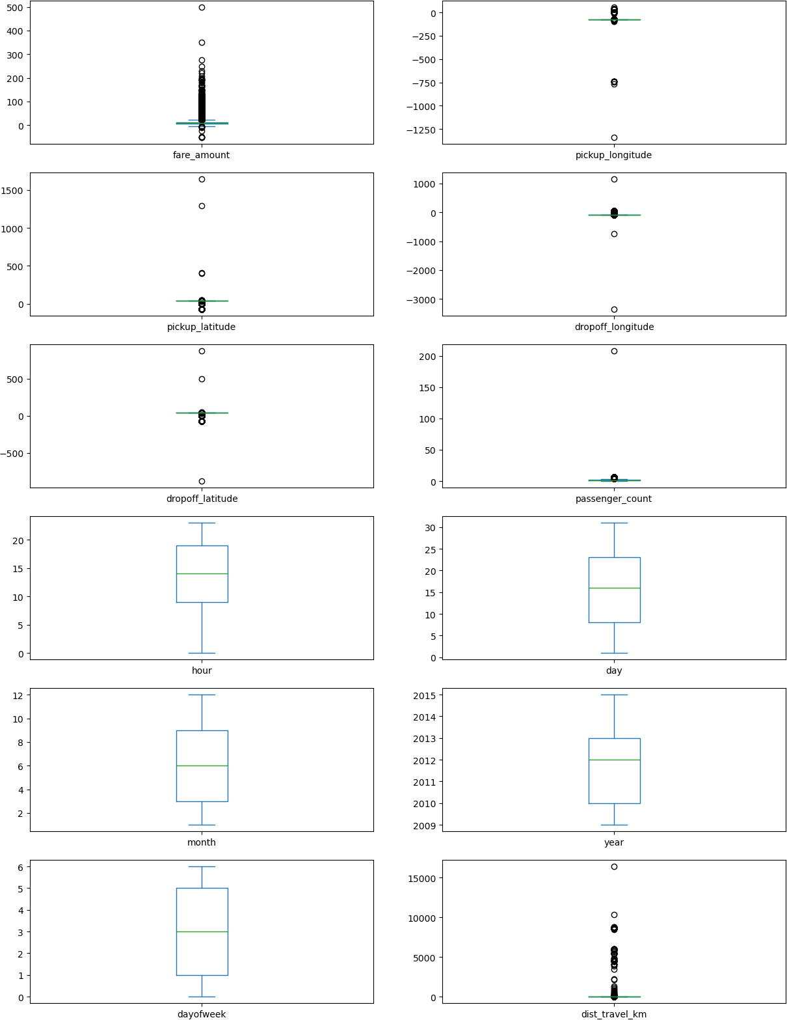

In [28]:
def remove_outlier(df1 , col):
#Calculate the first and third quartiles (Q1, Q3)
Q1 = df1[col].quantile(0.25) Q3 = df1[col].quantile(0.75)
#Interquartile range
IQR = Q3 - Q1

# Calculate lower and upper whiskers for outliers
lower_whisker = Q1-1.5*IQR upper_whisker = Q3+1.5*IQR
# Clip the values in the column to the whisker limits (remove outliers)
df[col] = np.clip(df1[col] , lower_whisker , upper_whisker)
return df1
def treat_outliers_all(df1 , col_list):
# Apply outlier treatment to each column in the list
for c in col_list:
df1 = remove_outlier(df , c)
return df1

In | [29]: | #condition for treating outliers  ## df = treat_outliers_all(df , df.iloc[: , 0::])
In | [30]: | # Select only numeric columns
 |  | numeric_cols = df.select_dtypes(include=['number']).columns
 |  | # Treat outliers in all numeric columns
 |  | df = treat_outliers_all(df, numeric_cols)
In | [31]: | # iloc stands for "integer location"  # primarily used for accessing and retrieving data from pandas DataFrame objects using i
 |  | #The iloc() function allows you to access specific rows and columns of a DataFrame by pr

In [32]:
#Boxplot shows that dataset is free from outliers
df.plot(kind = "box",subplots = True,layout = (7,2),figsize=(15,20)) plt.show()

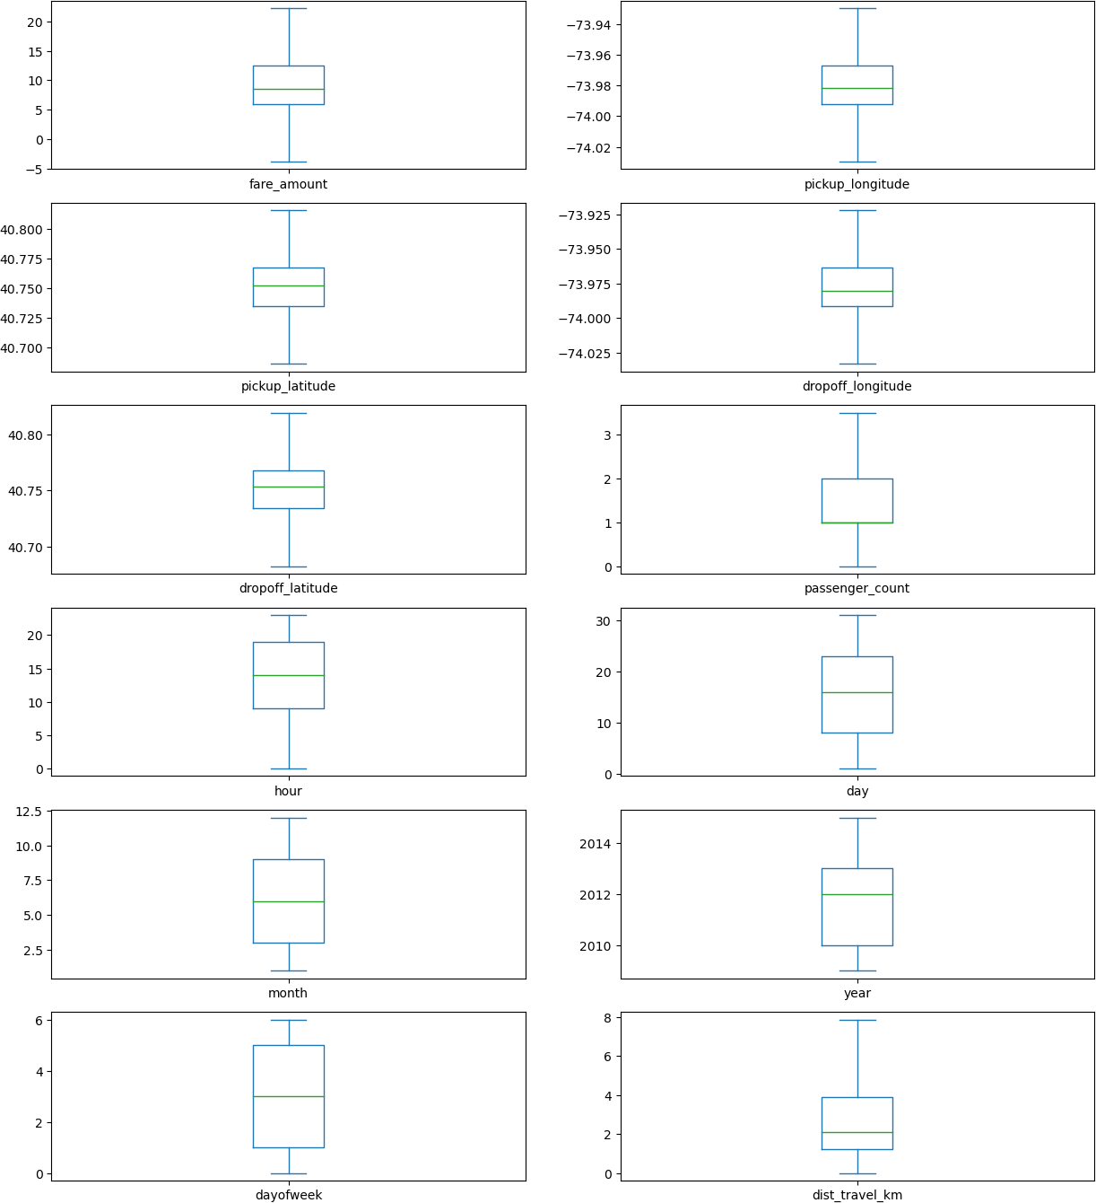

Check the correlaion

In [33]:
#Function to find the correlation
corr = df.corr() corr

Out[33]: | fare_amount | pickup_longitude | pickup_latitude | dropoff_longitude | dropoff_latitude | passenger_
fare_amount | 1.000000 | 0.154069 | -0.110842 | 0.218675 | -0.125898 | 0.0
pickup_longitude | 0.154069 | 1.000000 | 0.259497 | 0.425619 | 0.073290 | -0.0
pickup_latitude | -0.110842 | 0.259497 | 1.000000 | 0.048889 | 0.515714 | -0.0
dropoff_longitude | 0.218675 | 0.425619 | 0.048889 | 1.000000 | 0.245667 | -0.0

dropoff_latitude | -0.125898 | 0.073290 | 0.515714 | 0.245667 | 1.000000 | -0.0
passenger_count | 0.015778 | -0.013213 | -0.012889 | -0.009303 | -0.006308 | 1.0
hour | -0.023623 | 0.011579 | 0.029681 | -0.046558 | 0.019783 | 0.0
day | 0.004534 | -0.003204 | -0.001553 | -0.004007 | -0.003479 | 0.0
month | 0.030817 | 0.001169 | 0.001562 | 0.002391 | -0.001193 | 0.0
year | 0.141277 | 0.010198 | -0.014243 | 0.011346 | -0.009603 | -0.0
dayofweek | 0.013652 | -0.024652 | -0.042310 | -0.003336 | -0.031919 | 0.0
dist_travel_km | 0.844374 | 0.098094 | -0.046812 | 0.186531 | -0.038900 | 0.0

In [34]:
fig,axis = plt.subplots(figsize = (10,6))
sns.heatmap(df.corr(),annot = True) #Correlation Heatmap (Light values means highly corr

Out[34]:

In [35]:
# Dividing the dataset into feature and target values
x = df[['pickup_longitude','pickup_latitude','dropoff_longitude','dropoff_latitude','pas
<Axes: >
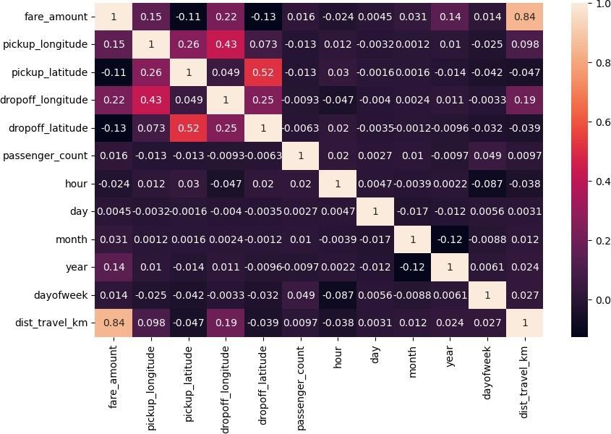

Implement linear regression and random forest regression models

In [36]:
y = df['fare_amount']

In [37]:
# Dividing the dataset into training and testing dataset
from sklearn.model_selection import train_test_split
x_train, x_test, y_train, y_test = train_test_split(x, y, test_size=0.2, random_state=1)

In [38]:
df.head()

Out[38]: | fare_amount | pickup_longitude | pickup_latitude | dropoff_longitude | dropoff_latitude | passenger_count | hour | da
 | 0 7.5 | -73.999817 | 40.738354 | -73.999512 | 40.723217 | 1.0 | 19
 | 1 7.7 | -73.994355 | 40.728225 | -73.994710 | 40.750325 | 1.0 | 20 | 1
 | 2 12.9 | -74.005043 | 40.740770 | -73.962565 | 40.772647 | 1.0 | 21 | 2
 | 3 5.3 | -73.976124 | 40.790844 | -73.965316 | 40.803349 | 3.0 | 8 | 2
 | 4 16.0 | -73.929786 | 40.744085 | -73.973082 | 40.761247 | 3.5 | 17 | 2

Linear Regression

In [39]:
from sklearn.linear_model import LinearRegression regression = LinearRegression()

In [40]:
regression.fit(x_train,y_train)


Out[40]:
▾ LinearRegression
LinearRegression()

In [41]:
regression.intercept_ #To find the linear intercept

Out[41]:

In [42]:

Out[42]:

In [43]:
2696.628508368316
regression.coef_ #To find the linear coeeficient
array([ 1.68594549e+01, -9.35694321e+00, 1.46515029e+01, -1.72166184e+01, 5.85708223e-02, 1.02541595e-02, 2.69553958e-03, 5.62328622e-02,
3.58490835e-01, -3.21230504e-02, 1.99987710e+00])
prediction = regression.predict(x_test) #To predict the target values

In [44]:
print(prediction)

In [45]:

Out[45]:
[ 6.27615184 5.09986098 9.43641238 ... 11.07663949 12.15392248
11.41496075]

y_test
49673 | 4.0
171551 | 6.1
5506 | 8.5
38370 | 4.9
36930 | 6.5
63840 | ...  10.7
128107 | 2.5
108940 | 10.0
199933 | 11.3
22902 | 12.5
Name: fare_amount, Length: 40000, dtype: float64

Metrics Evaluation using R2, Mean Squared Error, Root Mean Sqared Error

In [46]:
from sklearn.metrics import r2_score

In [47]:
r2_score(y_test,prediction)

Out[47]:

In [48]:
from sklearn.metrics import mean_squared_error
0.7539063007491047

In [49]:
MSE = mean_squared_error(y_test,prediction)

In [50]:
MSE

Out[50]:

In [51]:
RMSE = np.sqrt(MSE)
7.311380850569877

In [52]:
RMSE

Out[52]:

In [53]:
from sklearn.ensemble import RandomForestRegressor
2.7039565178770677

Random Forest Regression

In [54]:
rf = RandomForestRegressor(n_estimators=100) #Here n_estimators means number of trees yo

In [55]:
rf.fit(x_train,y_train)


Out[55]:
▾ RandomForestRegressor
RandomForestRegressor()

In [56]:
y_pred = rf.predict(x_test)

In [57]:
y_pred

Out[57]:

In [58]:
R2_Random = r2_score(y_test,y_pred)
array([ 4.838, 6.284, 9.18 , ..., 10.99 , 11.588, 13.756])

Metrics Evaluation for Random Forest

In [59]:
R2_Random
Out[59]: 0.8119252652187725

In [60]:
MSE_Random = mean_squared_error(y_test,y_pred)

In [61]:
MSE_Random

Out[61]:

In [62]:
RMSE_Random = np.sqrt(MSE_Random)
5.587652258230145

In [63]:
RMSE_Random
Out[63]: 2.363821536882627

